Des Plaines River Watershed Workgroup
Monitoring Committee
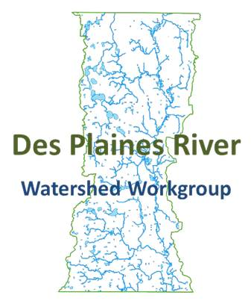
6/11/2015
10:30-11:30 AM
North Shore Water Reclamation District
14770 West William Koepsel Drive, Gurnee IL 60031

Outcomes:
- Provide input on the evaluation of the water and sediment chemistry proposals.

Agenda
**A quorum needs to be present**
Public Comment
Approval of Last Committee Minutes
Action Items
- Monitoring Committee Members – discuss monitoring committee membership number
  - Current Member List (Indications of Interest)
Joe Robinson
Austin McFarland
Mike Adam
Al Giertych
Mike Zemaitis
Jim Bland
Steve Vella
Rob Flood
Randy Seebach
KC Doyle
Mike Talbett
Mike Warner

- Water and Sediment Chemistry Proposal evaluation
Adjournment

