Des Plaines River Watershed Workgroup
Monitoring Committee
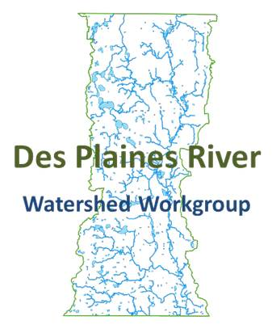
10/8/2015
1:30-3:00 PM
North Shore Water Reclamation District
14770 West William Koepsel Drive, Gurnee IL 60031

Outcomes:
- Map out a process for moving the Bioassessment RFP forward.
- Update the Committee on the current monitoring and QAPP progress.

Agenda
- Call the meeting to order
- Approval of 9/10/15 meeting minutes
- Public Comment
- Water Column Chemistry Monitoring Update
- QAPP
- Bioassessment RFP
- Next meeting
- Adjourn

