Des Plaines River Watershed Workgroup
Monitoring Committee
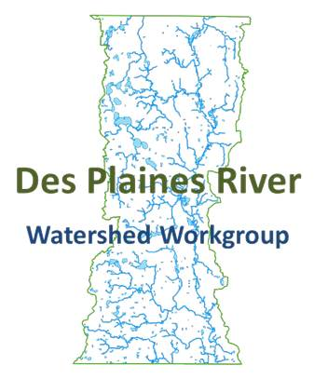
12/10/2015
9:00-10:00 AM
Lake County Central Permit Facility
500 W Winchester Road, Suite 200, Libertyville, 60048

Outcomes:
- Put forth a recommendation for the Bioassessment contractor to the Executive Board.

Agenda
- Call the meeting to order
- Approval of 10/8/15 meeting minutes
- Public Comment
- Water Column Chemistry Monitoring Update
- Bioassessment Proposal Evaluation
- Next meeting
- Adjourn

