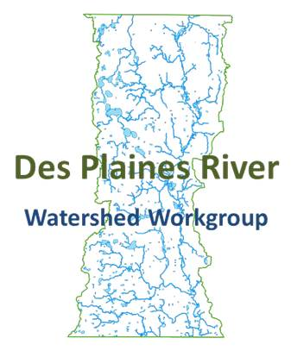
Des Plaines River Watershed Workgroup
Executive Board
12/10/2015
10:00-11:30 AM
Lake County Central Permit Facility
500 W. Winchester Road, Libertyville IL 60048

Outcomes:
- Approve Bioassessment contractor
- Approve Geosyntec agreement with LCSMC
- Determine next meeting dates

Agenda
- Call the meeting to order
- Approve 10/26/15 meeting minutes
- Public Comment
- Treasurer’s Report/DRWW Membership update
- Action Item: Approve Bioassessment contractor
- Action Item: Approve Geosyntec Agreement with LCSMC through April 30, 2016
- Action Item: Ratify Geosyntec Invoice #18152327 (October) in the amount of $3,000.
- Set Next Meeting Dates: Monthly Executive Board and Monitoring?
General Membership Meeting February 11th
- Adjourn

