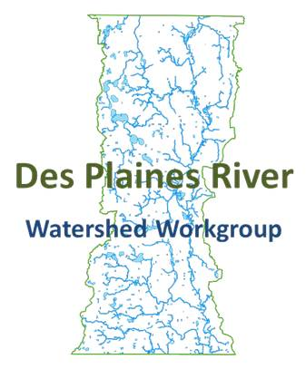
Des Plaines River Watershed Workgroup
Executive Board
12/10/2015
10:00-11:00 AM
Lake County Public Work, 650 Winchester Road, Libertyville IL 60048

Meeting Minutes
- Call the meeting to order: Peter Kolb called the meeting to order at 10:26 am.
- Approve 10/26/15 meeting minutes: Michael Talbett made a motion to approve the minutes, Joe Robinson seconded the motion. The motion passed unanimously.
- Public Comment: None
- Treasurer’s Report/DRWW Membership update: Mike Warner reported that we have received no new members since we last met. There was a discussion surrounding encouraging Mundelein to join.
There was also a discussion surrounding chloride variance. Lake County Public Works will monitor effluent and upstream and downstream of all plants in the Des Plaines on a monthly basis for chloride.
Discussed annual meeting agenda: Fred Andes. Quarterly summary report. KC Doyle to take minutes. Andrea Cline won’t be there.
- Action Item: Approve Bioassessment Contractor. Peter said the recommendation from the Monitoring Committee is to approve MBI as the bioassessment contractor without optional task 8 for flow monitoring, and approve a separate contract with Burns & McDonnell for task 8, flow monitoring without equipment. The DRWW could purchase the flow monitoring equipment for $16,000. Paul Kendzior suggested that we word the acceptance of the contract so that it states that upon completion of the contract, the equipment would be turned over to DRWW. SMC could provide them with the tax exempt number. Joe made a motion to accept the proposal for the bioassessment contract to MBI without optional task 8 for flow monitoring, contingent upon executing the contract, in an amount not to exceed $165,000, meeting the schedule developed by the Monitoring Committee (monitoring plan, QAPP). Paul Kendzior seconded. The motion passed unanimously.
Joe made a motion to accept the proposal flow monitoring study to Burns & McDonnell in an amount not to exceed $36,000, factoring in no more than 10% additional cost for mobilization, contingent upon contract approval, and that they provide us with the equipment at the end of the contract. Seconded by Brian Dorn. Unanimously approved.
- Action Item: Approve Geosyntec Agreement with LCSMC through April 30, 2016 for $33,000. Retroactive from December 1st, 2015. Mike W handed out Patty’s questions regarding the contract. Andrea will provide quarterly updates to SMC for Illinois EPA, the Section 319 grant. The final monitoring strategy and QAPP will be handled by MBI, per their proposal. Andrea will talk to Suburban Labs about putting the raw data into an Access database. Brian made a motion to accept the proposal by Geosyntec dated in the amount not to exceed of $33,000 for the period from December 1, 2015 through April 30, 2016. Joe seconded the motion. The motion passed unanimously. Peter asked what would happen after April 30th. Mike said there are three options: continue to contract with Geosyntec via contract amendment, go out for proposals, or provide SMC staff assistance. Mike Novotney could possibly do this task. He has the qualifications, SMC is not sure at this point that his work load will allow for the same level of service.
- Action Item: Ratify the payment Geosyntec Invoice #18152327 (October) in the amount of $3,000. Michael Talbett made the motion to ratify the invoices, Joe seconded the motion. The motion passed unanimously.
- Next Meeting: Mike W reported that he had a discussion with the Monitoring Committee about scheduling regular meetings. The same would be the best course of action for the Executive Board. We could cancel the meeting if not needed. Monitoring Committee would be moved up to 9:30 and the Executive Board at 11. Brian asked if we had to notify the local paper. Mike W said we follow Open Meetings Act, but we do not need to send to the local paper. NSWRD will be the location for the General Membership meetings. Committee meetings will be at the Lake County Central Permit Facility.
Membership Meeting February 11th, 10 am at NSWRD – Brian will talk to Fred Andes.
- Adjourn: Motion to adjourn was made by Michael, seconded by Joe. The motion passed unanimously. The meeting was adjourned at 11:23.
Executive Board Members Present:
Peter Kolb, Lake County Public Works
Brian Dorn, NSWRD
Michael Talbett, Kildeer
Paul Kendzior, Libertyville
Joe Robinson, NSWRD
Mike Adam, Lake County Health Department

Other Attendees:
Jim Bland, Sierra Club
Andrea Cline, Geosyntec
KC Doyle, Lake County
Austin McFarlane, Lake County Public Works
Paul Kendzior, Libertyville
Steve Vella, Libertyville
Mike Warner, Lake County SMC
Patty Werner, Lake County SMC

