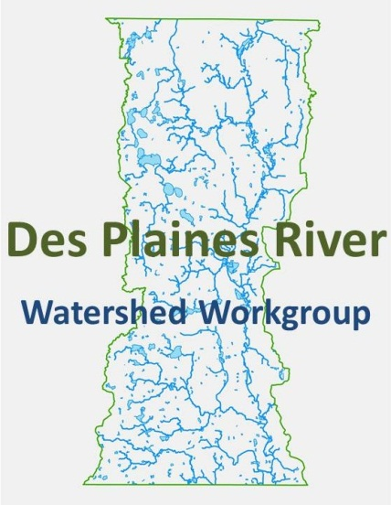

Des Plaines River Watershed Workgroup
Monitoring Committee
1/6/2015
10AM-11:30AM
Lake County Central Permit Facility
500 W. Winchester Road, Libertyville IL 60048

Outcomes:
- Discuss Bioassessment Contract

Agenda
- Call the meeting to order
- Approve Previous Meeting minutes
- Public Comment
- Action Item: Discuss Bioassessment Contract Scope
- Next General Membership Meeting February 11th
- Next Monitoring Committee February 18 – 9:30AM
- Adjourn

