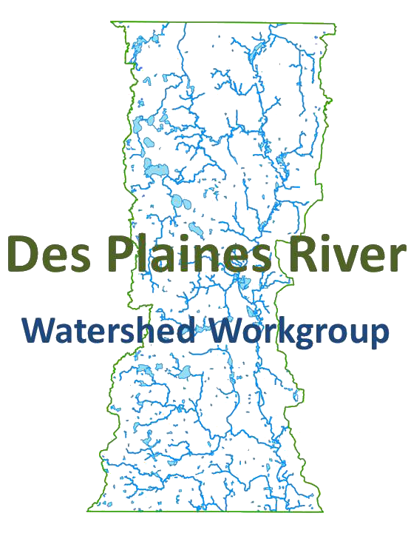

Des plaines River watershed workgroup
membership Meeting
NOVEMBER 12, 2015 10:00-12:00 PM
NORTH SHORE WATER RECLAMATION DISTRICT

MEETING MINUTES

Introductions and Announcements – Peter Kolb, Director of Public Works for Lake County and DRWW President, will conduct introductions and provide an overview of the meeting.
- Approve 8/13/15 meeting minutes. Brian Dorn motioned to approve the minutes, Paul Kendzoir seconded the motion. Scott Pippen and John Heinz were added to the list of attendees. The motion passed unanimously.

- Public Comment. None.
- MS4 NPDES Permit Update – Jeff Hutton, Bureau of Water Illinois EPA provided an update on the Municipal Separate Storm Sewer System National Discharge Elimination System permit, or the permit that covers conveyance systems that are not part of sewer or combined systems. A draft permit was put on public notice earlier this year that had quarterly wet weather monitoring requirements for permittees. Jeff’s presentation is available on the DRWW website.
- DRWW Business – Peter led the group in DRWW business matters.
  - Membership Update: Mike Warner provided the membership update. Lake County Forest Preserve District and the Village of Vernon Hills have joined since the last quarterly meeting. Randy Seebach was present on behalf of the Forest Preserve District. He thanked everyone for their continued support.
  - Committee Updates: Andrea Cline provided a summary of the October 26, 2015 Executive Board meeting. She reviewed the Request for Proposals for the Bioassessment which includes refinement of the monitoring plan; updating the Quality Assurance Project Plan; background data analysis; sampling of fish, macroinvertebrates, habitat, sediment, and field water chemistry; a report; and an optional flow monitoring task.
Mike Warner reviewed the DRWW finances. The DRWW fiscal year ends April 30th. The 2nd quarterly statement includes new member dues from Lake County Forest Preserve District and Vernon Hills. The DRWW has $220,547 in revenue and $17,841 in expenditures which is mostly for Geosyntec’s services, leaving a balance of $213,144. Dues for 2016 will be due June 1st. An invoice will be sent out.
The Monitoring Committee and Executive Board will meet both hold meetings on December 10th in order to evaluate the Bioassessment proposals and select a contractor.
    - Monitoring Committee: Joe Robinson updated the group on the water and sediment chemistry sampling. All 44 sites are being sampled, including the mainstem and tributary locations. Sampling takes place seven times a year, two sampling events have occurred so far (September and October) and one is scheduled to start November 30th. The October sampling event was during low flow conditions and included heavy metals.
A second RFP for the Bioassessment has been released. We need volunteers to review the proposals. At the next Monitoring Committee meeting a data management system will need to be discussed.
    - Lakes Committee: Mike Adam reported that the Committee will meet in January. If you’d like to serve on the Committee contact Mike or Andrea.
    - Impairments Committee: No report.
  - Secretary Replacement: Peter Kolb nominated Paul Kendzior from Libertyville as a replacement for Secretary for John Heinz who has retired. Brian Dorn seconded the motion. There was no discussion. The motion passed unanimously.
  - Quarterly Status Report: Quarterly status reports will be developed by Andrea for each Membership Meeting going forward so that each member has a readable, brief synopsis of DRWW activities.
- Next meeting: Quarterly meeting: February 11th
- Old business: Patty Werner announced that SMC has begun the stream and detention basin inventories as a part of the Des Plaines Watershed Plan.
- New business: None
- Adjournment: Paul Kendzior made a motion to adjourn. Mike Adam seconded the motion. The motion passed unanimously.

Members and Delegates Present:
Mike Adam, Lake County Health Department
Chris Carter, Village of Lindenhurst
Brian Dorn, North Shore Water Reclamation District
Al Giertych, Lake County DOT
Betty Harrison, Village of Lake Zurich
Logan Hawley, Cardno JFNew
Charles Hernandez, Village of Lindenhurst
Brandon Janes, Village of Deerfield
Paul Kendzior, Village of Libertyville
Peter Kolb, Lake County Public Works
Marcia McCutchan, RHMG representing
Austin McFarlane, Lake County Public Works
Joe Robinson, North Shore Water Reclamation District
Randy Seebach, Lake County Forest Preserve District
Michael Talbett, Village of Kildeer
Steve Vella, Village of Libertyville
Mike Warner, Lake County Stormwater Management Commission

Additional Attendees:
Adam Boeche, Village of Mundelein
Andrea Cline, Geosyntec Consultants
Ed Coggin, Weston Solutions
Leonard Dane, DEI
K.C. Doyle, Lake County
Erika Frable, Village of Hawthorn Woods
Abel Haile, Illinois EPA
Scott Hilts, Village of Round Lake Beach
Brian O’Neill, Burns McDonald
Paul Ruscko, HRGreen
Patty Werner, Lake County Stormwater Management Commission

